

NBI

User Documentation

Computer Studies Major Project

Lu Xin

2007

Content Page
NBI 1
Content Page 2
Installation Guide 3
Minimum hardware and software requirements 3
System & Application software needed 4
Step by Step Guide 4
Index 10

Installation Guide
To install the NBI Criminal Database on the pc’s in a network, it is advised that this is installed on the main computer so all the users can access it at a central point.
To run this program, you will need to follow 3 simple steps:
- Install eclipse 3.0 or higher which has visual support.
- Copy the program into the work space of eclipse OR press File > Import > Existing project into Workspace > location of program folder.
- Then open the RunProgram class and run it, or just double-click the NBI.jar file.

Minimum hardware and software requirements
You would require the following to install and use the program.
- A Computer
- Windows 95 or Higher. Mac OS
- 128 MB RAM.
- CD Reader.
- 500 MB of free hard drive space to install eclipse and the program

System & Application software needed

System software: You will require Java Virtual Machine 1.0 or higher
Application software: You will be required to install Eclipse SDK. This is included on the CD and is also available on the net as it is freeware.

Step by Step Guide
LOGIN: The login will take you to your personal page:

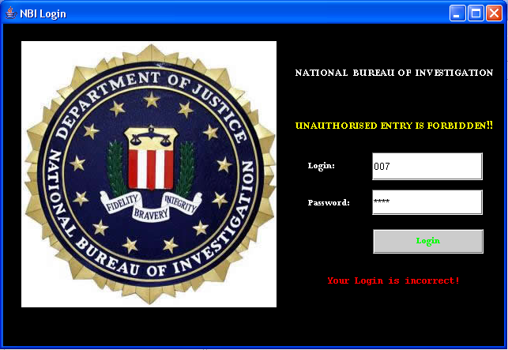
PERSONAL PAGE: Once your login was accepted, it will take you here. You will have the option to view criminals, and see your email. Only ADMINS will be allowed to manage users.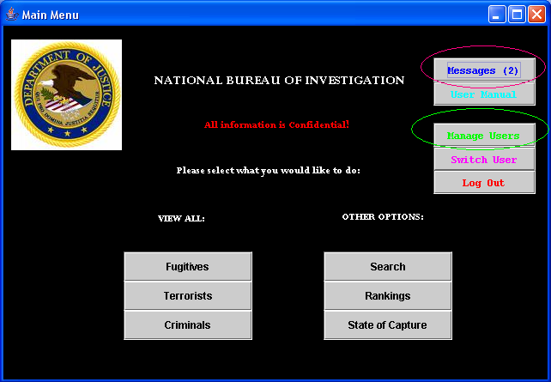
If you select “Fugitives”, “Terrorists”, or “Criminals”, the program will take you to a page where you will be able to view all the people under that description. You will have the option to view their details.
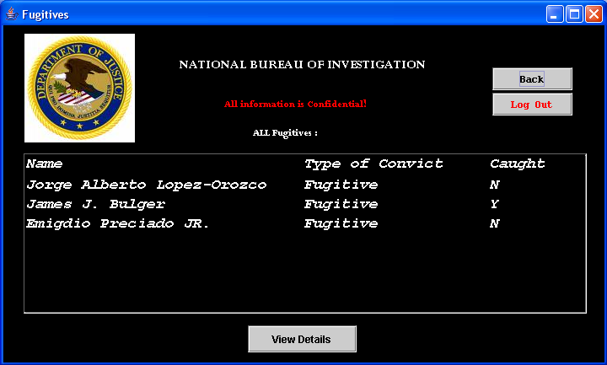
If you select Search, You will be able to search by the method of your choice. If search has results, it will display them and give you an option to see their details; else it will give an error.
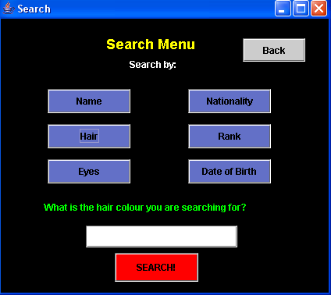
Not Found
Found
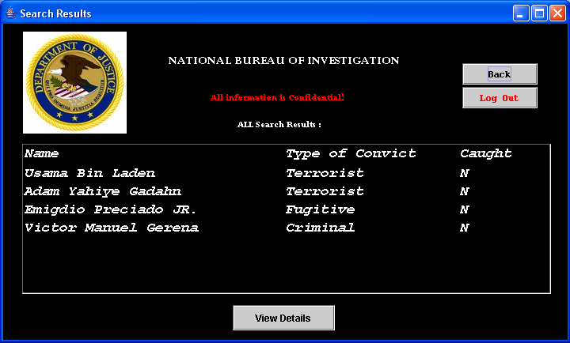
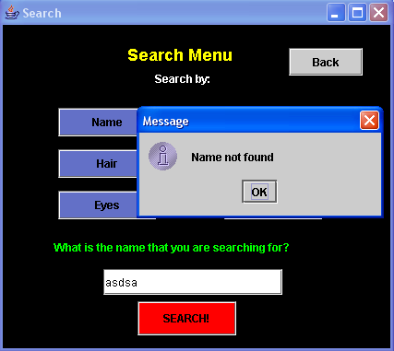

If you select rankings, you will be able to see all the convicts placed in order by how wanted they are by the FBI and their price money. You will have the option to view their details.

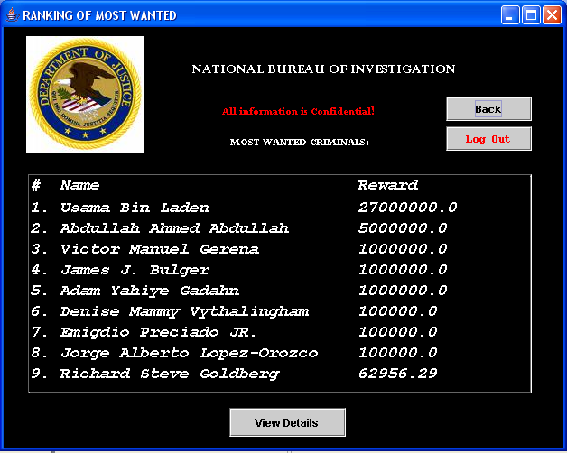
If you selected State of Capture, here you will see all those criminals who are caught and those who are still at large. You can change their status as well as view their details.
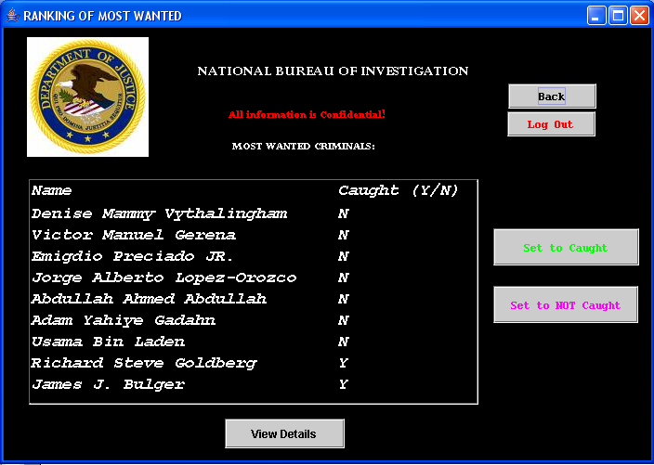
If you press View detail at any stage, you will be able to see the person’s details with a picture included. The edit option will also be available here.
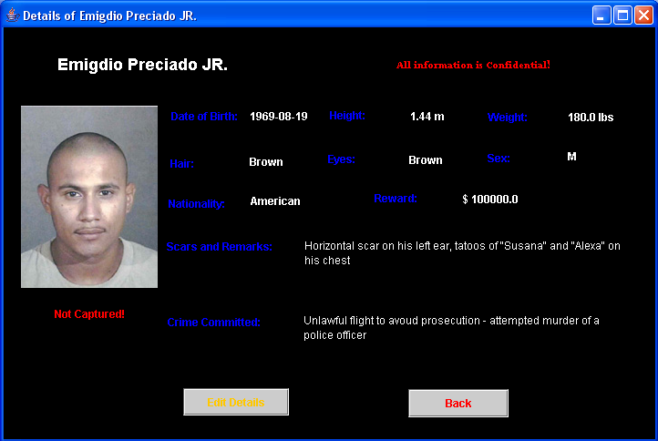
If you do decide to edit the details, you can, if a detail is incorrect IE weight is not a number, an error message will be given.
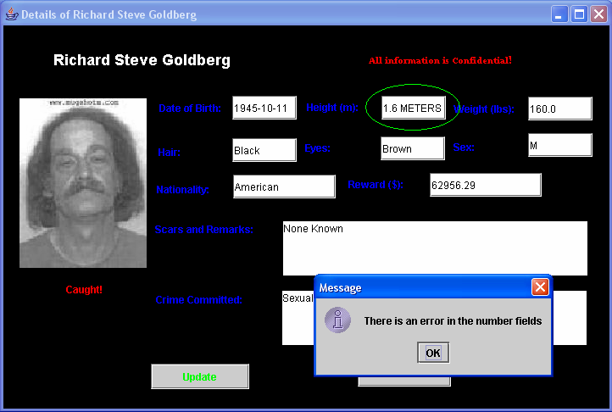
If you select Messages in the main menu, you will be able to see all your received messages and sent ones.
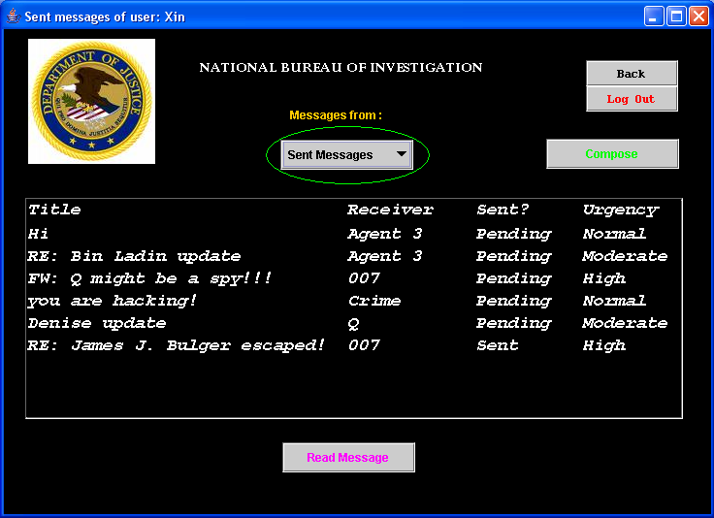
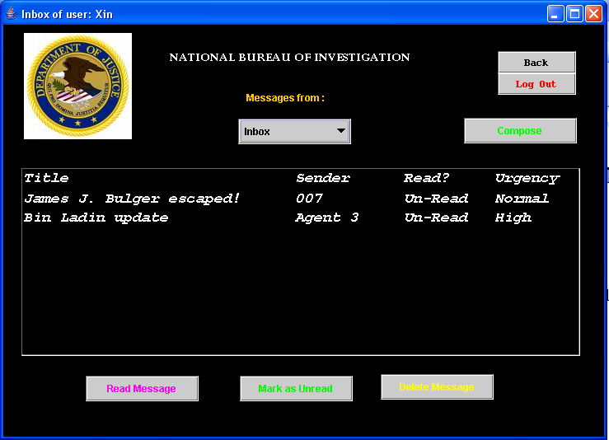

(Notice you will not be able to delete or mark a message as unread if you’ve sent them)
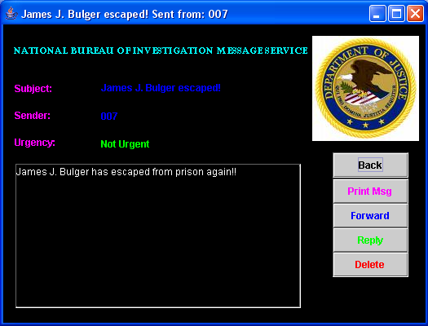
If you press read message, you will be able to see the body of the message. You will also have the option to print, reply or forward the message.

If you select compose, you will be taken to the new messages window. If u wanted to reply to a message, the subject and receiver will be set automatically for you. If u wanted to forward, the title and body will be automatically set for you too. You may send a message to more than one person by adding them to a list.
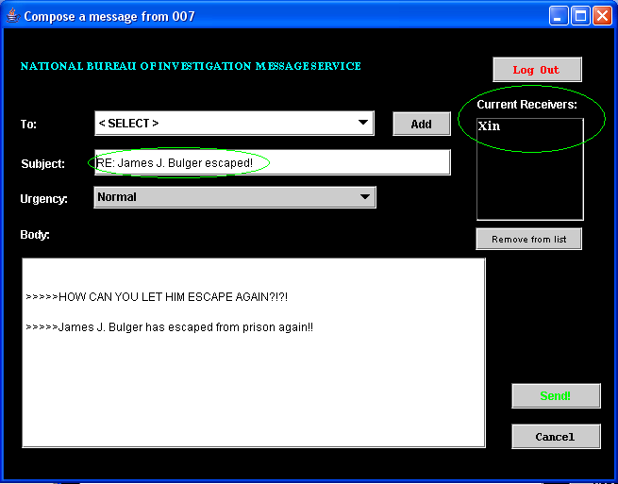

Index

Criminals, 5
delete, 9
description, 5
details, 5, 6, 7
forward, 9, 10
Fugitives, 5
Guide, 2, 3
Installation Guide, 3
LOGIN, 3
message, 7, 9
PERSONAL, 4
print, 9
program, 3, 5
rankings, 6
received, 8
reply, 9
requirements, 2, 3
Search, 5
sent, 8, 9
software, 2, 3
status, 6
Terrorists, 5
users, 3, 4

